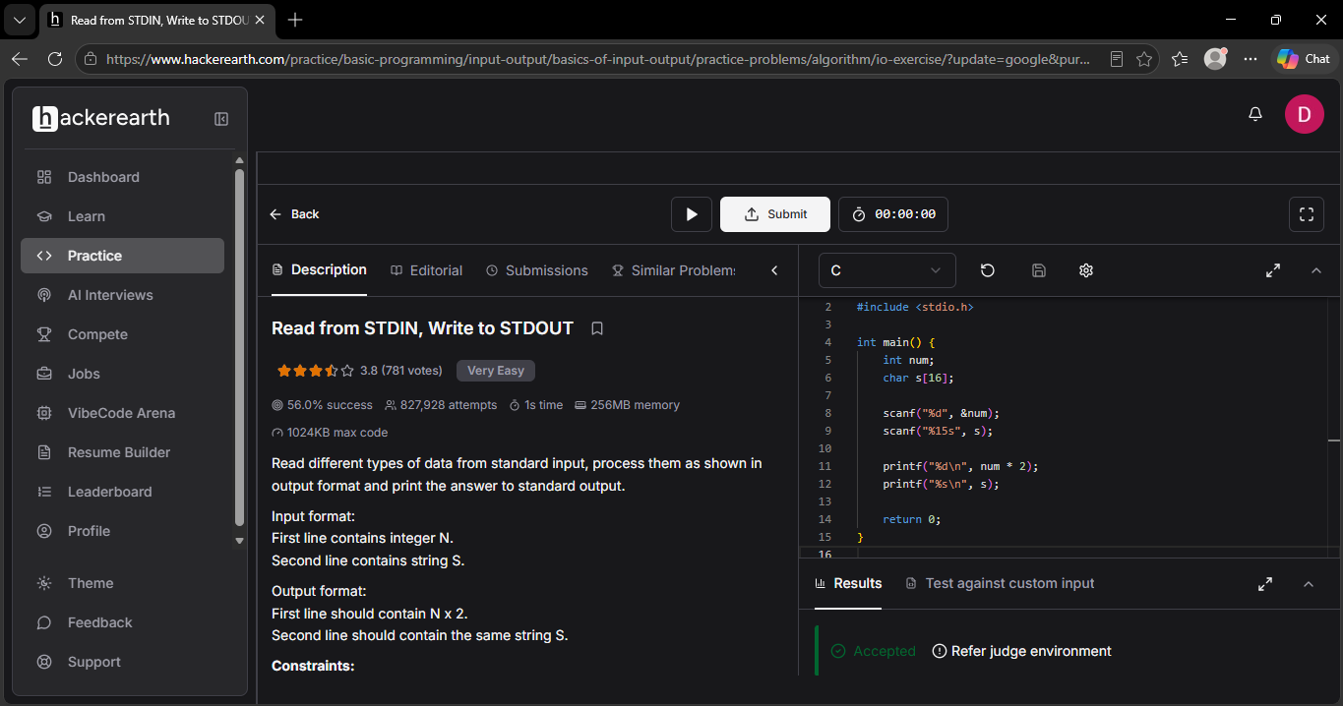

Q 1 #include <stdio.h>

int main() {
int num;
char s[16];

scanf("%d", &num);
scanf("%15s", s);

printf("%d\n", num * 2);
printf("%s\n", s);

return 0;
}

